Confidence Intervals and Bootstrapping Exercises
Charley Kirk
10/31/2024
ModernDive is under a Creative Commons Attribution - NonCommercial - ShareAlike 4.0 license so it is able to be modified with attribution as above.
This assignment is based on one by Albert Kim and Jenny Smetzer designed to accompany the book.

Background
In this problem set we will use a small sample of data from the General Social Survey. The survey is designed to monitor changes in both social characteristics and attitudes in adults. You will work with a sample from one neighborhood. The full neighborhood of ALL adult individuals is the population. For this problem set we do not know the true population parameters for any of the variables, because we do not have data on every person in the neighborhood.

Setup
First load the necessary packages
# Recall that loading the tidyverse "umbrella" package loads ggplot2, dplyr, and
# readr all at once. Feel free to load these packages any way you choose.
library(tidyverse)
library(moderndive)
library(infer)
Next load the data set, from where it is stored on the web:
gss_sample <- read_csv("https://docs.google.com/spreadsheets/d/e/2PACX-1vSypSoDCMH2N76Vo2dZRPkw2q3t1mbvAXlOtgPDIsHg4NclAQFmER-BdvXH9_lrT40UQCVdPXOi_NMJ/pub?gid=257689625&single=true&output=csv")
glimpse(gss_sample)
## Rows: 100
## Columns: 3
## $ age <dbl> 79, 23, 31, 53, 39, 59, 45, 84, 52, 60, 21, 25, 56, 68, 58, 42…
## $ race <chr> "White", "White", "POC", "White", "White", "White", "White", "…
## $ tvhours <dbl> 1, 1, 4, 4, 1, 1, 2, 3, 4, 3, 0, 3, 1, 3, 4, 1, 1, 2, 1, 5, 2,…
Be sure to take a look at the data either by typing in the data set name and hitting play or in the viewer. Each row in the data set is a person that was surveyed (100 rows or cases in total). The variables in the data set include each respondent’s age, race, and number of hours of TV watched a day tvhours.
Setting a seed: We will take some random samples and build sampling distributions in this lab. In order to make sure R takes the same random sample every time you run your code, you can do what is called “setting a seed”. Do this in any code chunk that you take a random sample!
You can set a seed like so. Any number will do.
set.seed(94)

Confidence intervals for one mean
We are first going to look at the number of hours of tv watched a day, tvhours.

Question 1
What parameter would we try to estimate with tvhours? Why?
Answer:.
Probably the mean tv hours, since that gives us an idea of what tv hours we might expect from a random individual.

Step 1: Make the bootstrap distribution
Using specify-> generate-> calculate
set.seed(51)
bootDistTV=gss_sample %>%
specify(response=tvhours) %>%
generate(reps=1000, type="bootstrap") %>%
calculate(stat="mean")
bootDistTV
## Response: tvhours (numeric)
## # A tibble: 1,000 × 2
## replicate stat
## <int> <dbl>
## 1 1 3.19
## 2 2 3.36
## 3 3 3.15
## 4 4 3.32
## 5 5 3.11
## 6 6 3.06
## 7 7 3.14
## 8 8 3.39
## 9 9 3.25
## 10 10 3.13
## # ℹ 990 more rows
visualize(bootDistTV)
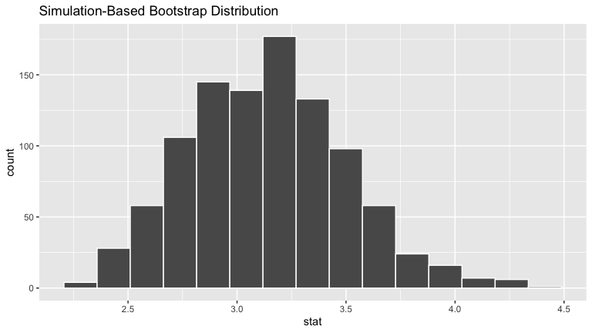

Question 2
What bootstrap statistics are we using? How many values of the bootstrap statistic boot_stat are there? Please explain why there are this many values of the bootstrap statistic.
Answer:.
We are using bootstrap statistics constructed from samples made with bootstrap resampling with replacement. There are 1,000 estimated values of the mean statistic because we used 1,000 replicates, or in other world we resampled 1,000 times.

Step 3: CI from a bootstrap resample

a) Bootstrap CI using the standard error
Now let’s make the 95% (normal) bootstrap confidence interval using the standard error.
point_est=mean(gss_sample$tvhours)
point_est
## [1] 3.14
standard_error_ci <- bootDistTV %>%
get_confidence_interval(type = "se",level=.95, point_estimate = point_est)
standard_error_ci #level defaults to 95%, but is listed here so you can change it if you'd like
## # A tibble: 1 × 2
## lower_ci upper_ci
## <dbl> <dbl>
## 1 2.43 3.85
visualize( bootDistTV) +
shade_confidence_interval(endpoints = standard_error_ci)
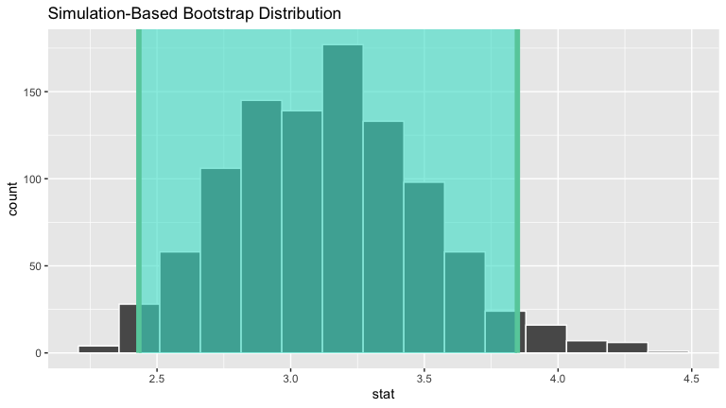

Question 3
Write a sentence interpreting the interval in context.
Answer:.
We have 95% confidence that the confidence interval contains the true population mean.

b) 95% Bootstrap CI using percentile method
percentile_ci <-bootDistTV%>%
get_confidence_interval(level = 0.95, type = "percentile")
percentile_ci
## # A tibble: 1 × 2
## lower_ci upper_ci
## <dbl> <dbl>
## 1 2.50 3.9
visualize( bootDistTV) +
shade_confidence_interval(endpoints = percentile_ci)
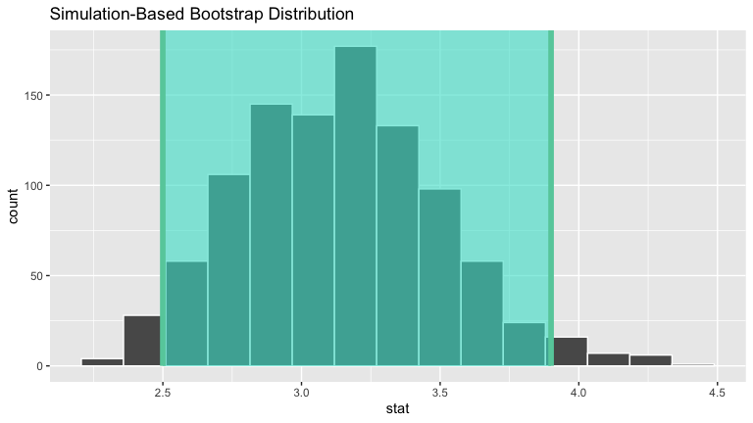

Question 4
If we calculated a 90% confidence interval for the mean of tvhours using this same bootstrap resample and the percentile method, roughly how many of the 1000 values of stat (the bootstrap statistic) would fall between the green lines?
Answer:
Probably about 900.

Question 5
Use the bootstrap resampling distribution for tvhours generated above (bootDistTV) and the percentile method to calculate a 99% confidence interval for the mean tvhours. Write a sentence interpreting the confidence interval in context.
Answer:.
percentile_ci<-bootDistTV%>%
get_confidence_interval(level=0.99, type = "percentile")
visualize(bootDistTV)+
shade_confidence_interval(percentile_ci)
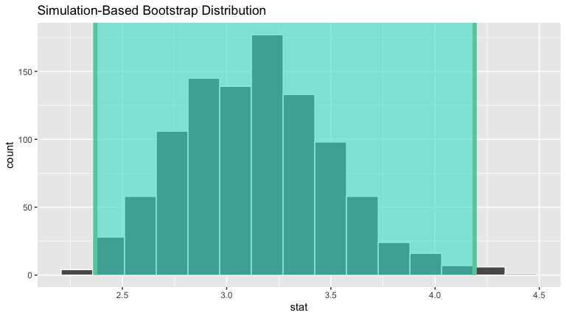
We have 99% confidence that the confidence interval contains the true population mean.

Question 6
Which confidence interval is WIDER: the 95% confidence interval or the 99% confidence interval for the population mean tvhours $μ_{tv}$? Why?
Answer:
The 99% confidence interval is wider, because in order to have greater confidence the interval needs to capture more of the possible values.

Confidence intervals based on the theoretical normal distribution
As we did in the examples, we’ll just look at the confidence interval part from the R routine that makes theoretical based inference. It uses a more exact distribution for means, the t-distribution (for this sample size they are quite close), which is why it is called a t-test. Note that the name t-test is commonly used, but not a great name because it doesn’t directly tell you that you are working with means.
t.test(gss_sample$tvhours, alternative="two.sided")$conf
## [1] 2.427075 3.852925
## attr(,"conf.level")
## [1] 0.95

Question 7
In order to use the method we just used, we need either a large sample or the variable we are using to be normally distributed. Here the sample size is large enough (generally over 30 is large enough if the data is not horribly skew). However for the practice, make a histogram of the tvhours variable. Is it approximately bell shaped/normally distributed? Why or why not?
Answer:
gss_sample%>%
ggplot(aes(tvhours))+
geom_histogram()
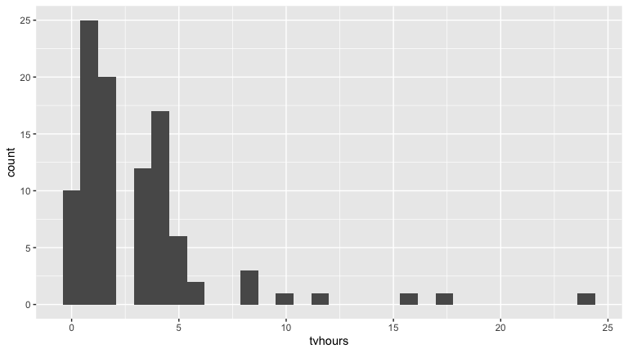
The tvhours histogram is quite right-skewed and thus not bell shaped/normally distributed.

Question 8
Write down the three 95% confidence intervals for the population mean of tvhours $μ_{tv}$ you’ve computed in this problem set. Do this by replacing X, Y, A, B, P, and Q with the appropriate values you’ve computed.
When you are done, make sure all the | in the table still line up so your results print out in a table when you knit to Word!
CI construction method | lower value | upper value
Using bootstrap: 95% rule | 2.432166 | 3.847834
Using bootstrap: percentile rule | 2.49975 | 3.9
Using theoretical methods | 2.427075 | 3.852925
In your opinion: would you say these three confidence intervals are similar?
Answer:
Yes, I would say they all look pretty close to each other.

Question 9
Now we will look at the variable age, the age of the person filling out the survey.
- Make a bootstrap distribution for mean age.
Answer:
bootDistAge<-gss_sample%>%
specify(response = age)%>%
generate(reps = 1000, type="bootstrap")%>%
calculate(stat = "mean")
- Calculate a 95% bootstrap confidence interval for the population mean age $μ_{age}$ using the standard error (normal) method. Write a sentence interpreting the confidence interval in context.
Answer:
point_est<-mean(gss_sample$age)
percentile_ci<-bootDistAge%>%
get_confidence_interval(level = 0.95, type="se", point_estimate = point_est)
percentile_ci
## # A tibble: 1 × 2
## lower_ci upper_ci
## <dbl> <dbl>
## 1 44.2 51.1
We have 95% confidence that the confidence interval contains the true population mean for age.
- Calculate a 99% confidence interval for the population mean age $μ_{age}$ using the percentile method. Write a sentence interpreting the confidence interval in context.
Answer:
percentile_ci<-bootDistAge%>%
get_confidence_interval(level = 0.99, type="percentile", point_estimate = point_est)
percentile_ci
## # A tibble: 1 × 2
## lower_ci upper_ci
## <dbl> <dbl>
## 1 43.3 52.0
We have 99% confidence that the confidence interval contains the true population mean for age.
- Calculate a 90% confidence interval for or the population mean age $μ_{age}$ using the theoretical method. Make sure to say why this method is appropriate. Write a sentence interpreting the confidence interval in context.
Answer:
x_bar<-mean(gss_sample$age)
sd<-sd(gss_sample$age)
se<-sd/sqrt(100)
upper_ci<-x_bar+1.645*se
lower_ci<-x_bar-1.645*se
data.frame(lower_ci, upper_ci)
## lower_ci upper_ci
## 1 44.75207 50.46793
This method is appropriate because the expression sd/sqrt(100) gives an estimate of the standard error of the sampling distribution for the sample mean, and it can be shown that 90% of values are within +-1.645 standard errors of the sample mean. We have 90% confidence that the confidence interval contains the true mean of age in the population.

Confidence intervals for one proportion
We will work with the variable race.

Question 10
What parameters could we try to estimate with race? Why?
Answer:
We could estimate either the proportion/percentage of White or the proportion/percentage of POC. Note software does proportions but you can interpret results in percentages if wanted.

Question 11
Using the example in the ConfidenceIntervalExamples.Rmd for a single proportion do the following.
- Make a bootstrap distribution for the proportion of POC, people of color, using specify-> generate-> calculate
Answer:
bootDistPOC=gss_sample %>% specify(response=race, success="POC") %>% generate(reps=1000, type="bootstrap") %>% calculate(stat="prop")
visualize(bootDistPOC)
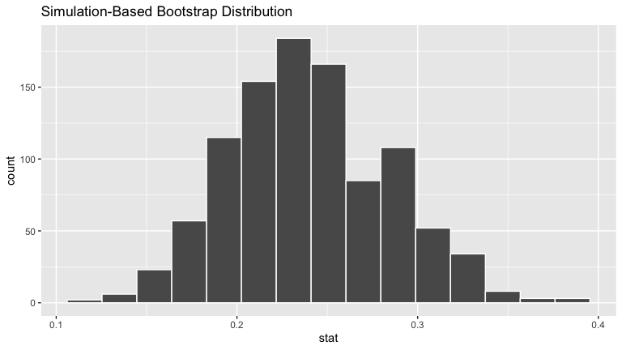
- Calculate a 95% bootstrap confidence interval for the population proportion of POC,$p_{POC}$, using the standard error (normal) method. Write a sentence interpreting the confidence interval in context.
Answer:
point_est=mean(gss_sample$race=="POC")
point_est
## [1] 0.24
standard_error_ci <- bootDistPOC %>%
get_confidence_interval(type = "se",level=.95, point_estimate = point_est)
standard_error_ci
## # A tibble: 1 × 2
## lower_ci upper_ci
## <dbl> <dbl>
## 1 0.156 0.324
We have 95% confidence that the confidence interval contains the true proportion of POC in the population.
- Calculate a 99% confidence interval for the for the population proportion of POC, $p_{POC}$, using the percentile method. Write a sentence interpreting the confidence interval in context.
Answer:
percentile_ci <- bootDistPOC %>%
get_confidence_interval(type = "percentile", level=.99)
percentile_ci
## # A tibble: 1 × 2
## lower_ci upper_ci
## <dbl> <dbl>
## 1 0.14 0.360
We have 99% confidence that the confidence interval contains the true proportion of POC in the population.
- Calculate a 90% confidence interval for or the population proportion of POC, $p_{POC}$, using the theoretical method. Make sure to say why this method is appropriate. Write a sentence interpreting the confidence interval in context.
Answer:
se<-sqrt(point_est * (1 - point_est) / 100)
upper_ci<-point_est+1.645*se
lower_ci<-point_est-1.645*se
data.frame(lower_ci, upper_ci)
## lower_ci upper_ci
## 1 0.1697448 0.3102552
This method is appropriate because the expression sqrt(point_est * (1 - point_est) / 100) gives an estimate of the standard error of the sampling distribution for the sample proportion, and it can be shown that 90% of values are within +-1.645 standard errors of the sample proportion. We have 90% confidence that the confidence interval contains the true proportion of POC in the population.

Confidence intervals for the difference in two means
We will work with the variables tvhours and race together.

Question 12
What parameters could we try to estimate with tvhours and race together? Why?
Answer:
We could try to to estimate the mean tvhours for white people and the mean tvhours for people of color. We can do this because it might tell us something interesting about the difference in tv watching habits by race.

Question 13
Using the example in the ConfidenceIntervalExamples.Rmd for a difference in means do the following.
- Make a bootstrap distribution for the difference between mean tvhours for White - mean tvhours for POC using specify-> generate-> calculate. Note that we have chosen the order of subtraction.
Answer:
bootDistTVRace = gss_sample %>% specify(formula= tvhours~race) %>%generate(reps=1000) %>% calculate(stat = "diff in means", order = c("White","POC"))
bootDistTVRace
## Response: tvhours (numeric)
## Explanatory: race (factor)
## # A tibble: 1,000 × 2
## replicate stat
## <int> <dbl>
## 1 1 0.48
## 2 2 -1.25
## 3 3 -0.641
## 4 4 0.367
## 5 5 0.370
## 6 6 -1.55
## 7 7 -1.34
## 8 8 -0.0949
## 9 9 0.445
## 10 10 -0.422
## # ℹ 990 more rows
visualize(bootDistTVRace)
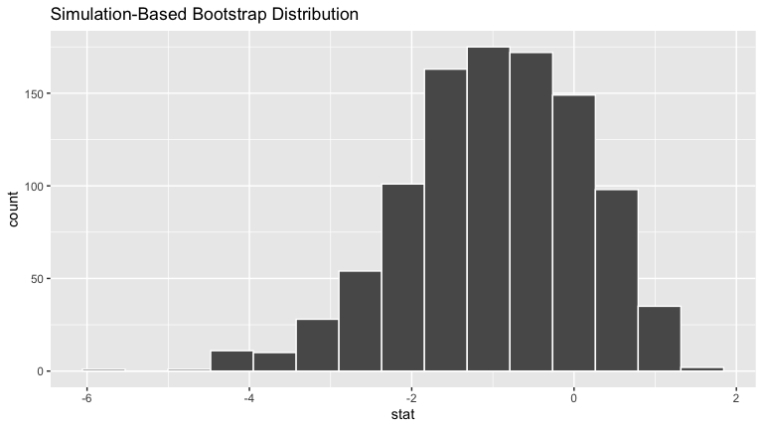
- Calculate a 95% bootstrap confidence interval for the difference in mean hours of daily tv for White -POC, $μ_{White}−μ_{POC}$, using the standard error (normal) method. Write a sentence interpreting the confidence interval in context.
Answer:
gss_sample%>%
group_by(race)%>%
summarise(mean=mean(tvhours))
## # A tibble: 2 × 2
## race mean
## <chr> <dbl>
## 1 POC 3.88
## 2 White 2.91
point_est<-2.907895-3.875000
point_est
## [1] -0.967105
bootDistTVRace%>%
get_confidence_interval(point_estimate = point_est, type="se", level = 0.95)
## # A tibble: 1 × 2
## lower_ci upper_ci
## <dbl> <dbl>
## 1 -3.13 1.19
Normally I would say we have 95% confidence that the confidence interval contains the true value of population mean tvhours for white people - population mean tvhours for people of color, but the corresponding bootstrap distribution is actually rather left skewed so the standard error method might not be adequate here.
- Calculate a 99% confidence interval for the difference in mean hours of daily tv for White -POC, $μ_{White}−μ_{POC}$, using the percentile method. Write a sentence interpreting the confidence interval in context.
Answer:
bootDistTVRace%>%
get_confidence_interval(type="percentile", level = 0.99)
## # A tibble: 1 × 2
## lower_ci upper_ci
## <dbl> <dbl>
## 1 -4.22 1.08
We have 99% confidence that the confidence interval contains the true value of population mean tvhours for white people - population mean tvhours for people of color.
- Calculate a 90% confidence interval for the difference in mean hours of daily tv for White -POC, $μ_{White}−μ_{POC}$,using the theoretical method. Make sure to say why this method is appropriate. Write a sentence interpreting the confidence interval in context.
Answer:
point_est<-2.907895-3.875000
white<-gss_sample%>%
filter(race=="White")%>%
summarise(mean=mean(tvhours), sd=sd(tvhours), n=n())
poc<-gss_sample%>%
filter(race=="POC")%>%
summarise(mean=mean(tvhours), sd=sd(tvhours), n=n())
se<-sqrt(((white$sd)^2)/white$n+((poc$sd)^2)/poc$n)
upper_ci<-point_est+1.645*se
lower_ci<-point_est-1.645*se
data.frame(lower_ci, upper_ci)
## lower_ci upper_ci
## 1 -2.827631 0.8934211
This method is appropriate because the expression assigned to se gives an estimate of the standard error of the sampling distribution for the difference in sample means, and it can be shown that 90% of values are within +-1.645 standard errors of the point estimate. We have 90% confidence that the confidence interval contains the true difference in means for White and POC tv hours in the population.
- What does the spread of plausible values of the difference in means in these intervals tell you about the difference between White and POC daily hours of tv watching?
Answer:
The intervals contain 0, so it’s likely that there’s no actual difference in the population means for White and POC daily hours of tv watching.

